Deploying an application on Elastic Beanstalk
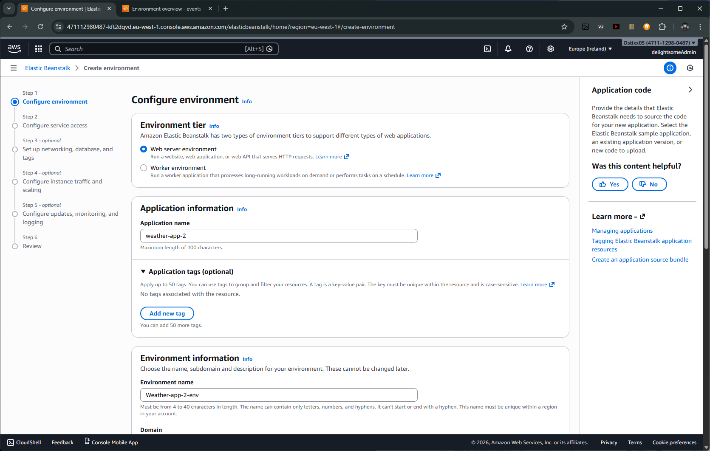
For the purpose of this walkthrough, I’m creating this weather app. We won’t be coding it from scratch as the source code has been provided already. Feel free to clone the repo [here] (Github link).
Here, I named it and left the domain blank. This way, AWS generates one for me. The application was built using .NET8 so my platform would be .NET Core on Linux, Plastform branch, .NET 8 running on 64bit Amazon Linux 2023 and I’m sticking with the recommended platform version.
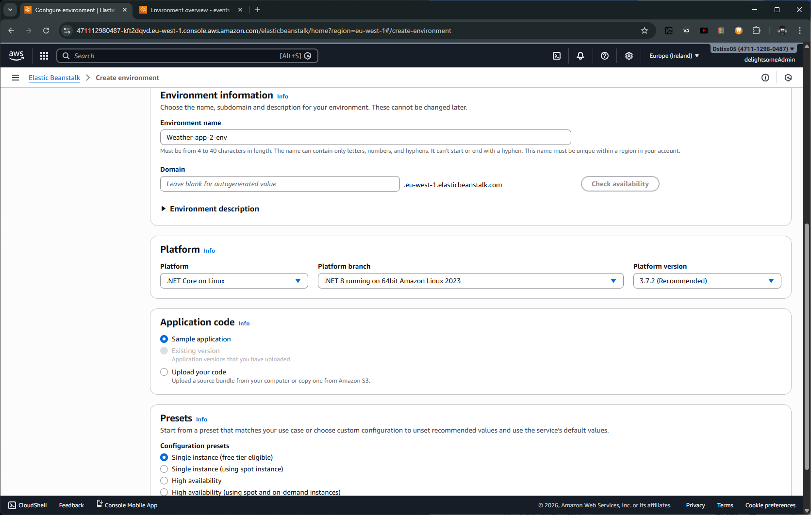

Configuring Service Access
In this part of the configuration, we attach an IAM role to elastic beanstalk. This would give it permission to use the necessary services for our project. We’ll also create an EC2 instance profile that will be attached to all the EC2 instances beanstalk will spin up.
I already created a service role called eb-service-role and attached the following AWS-managed policies to it.
AutoScalingFullAccess AWSElasticBeanstalkEnhancedHealth AWSElasticBeanstalkManagedUpdatesCustomerRolePolicy AWSElasticBeanstalkMulticontainerDocker AWSElasticBeanstalkWebTier AWSElasticBeanstalkWorkerTier
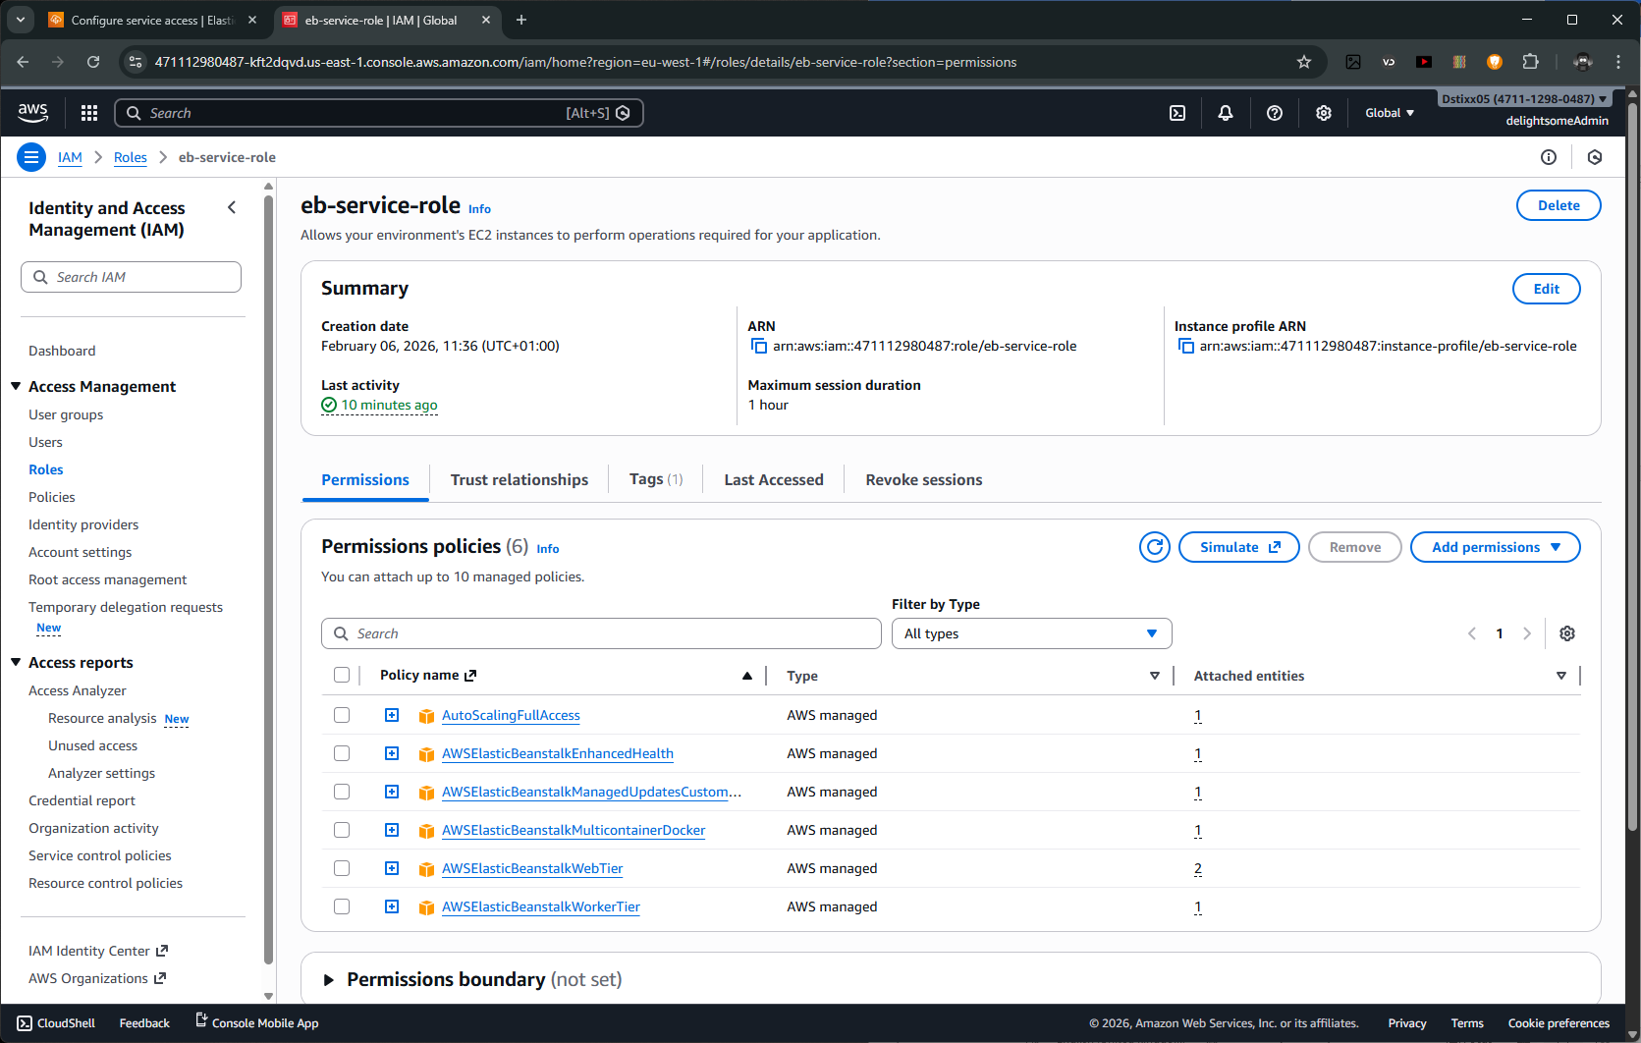

It’s important to also attach a trust policy to this role. This let’s Beanstalk assume the role and if not attached, Beanstalk won’t be able to assume the role. In fact, it won’t show.
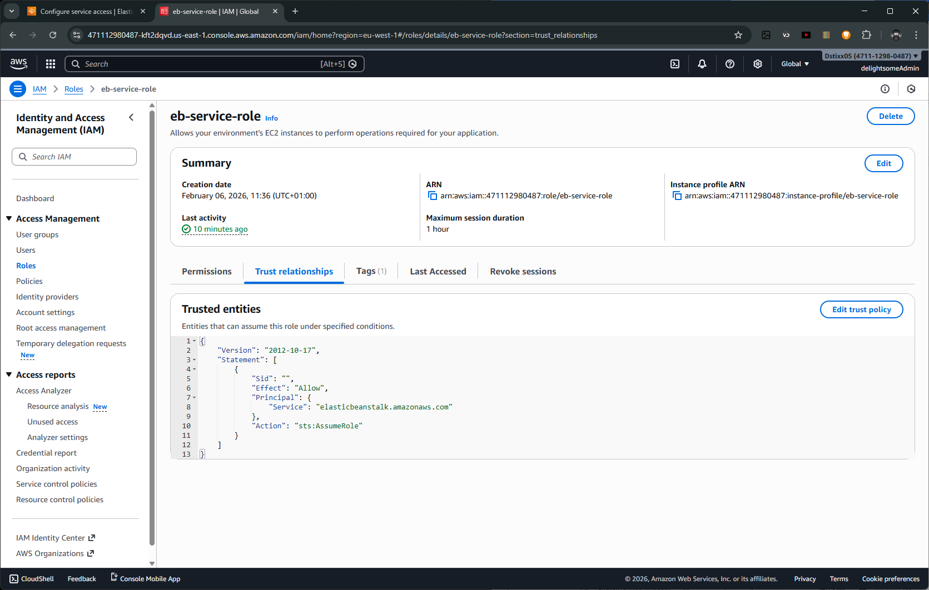

For the instance profile, I create a role aws-elasticbeanstalk-ec2-role and attached the AWS-managed AWSElasticBeanstalkWebTier. This gives our EC2 instances permission to access S3 buckets, AWS Xray, CloudWatch logs and Beanstalk Health Access which would come in very helpful when we’re scaling out.
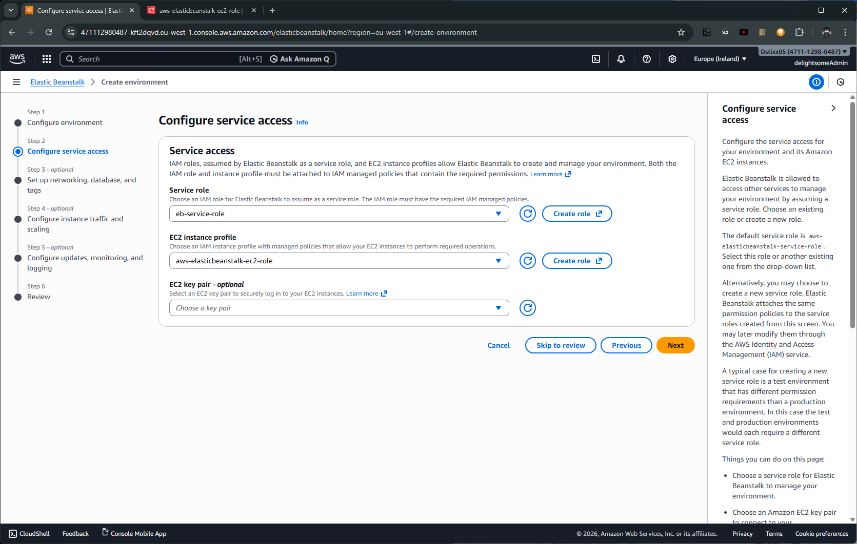

Now, to setting up networking, dbs and tags, 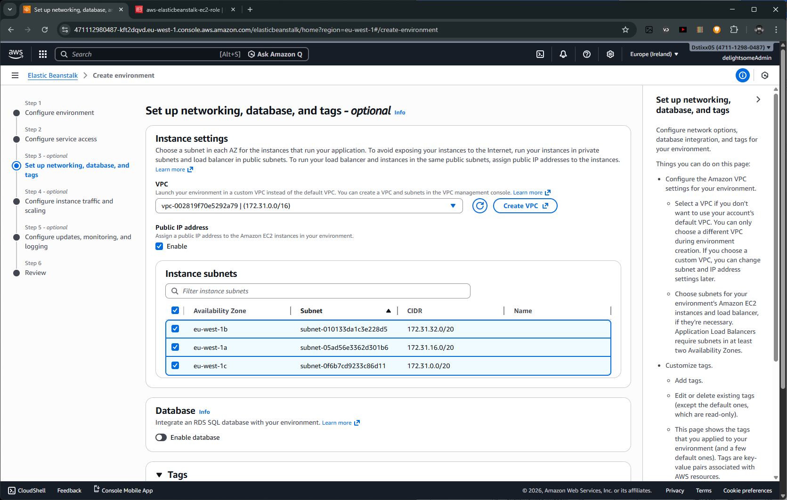
Here, I stuck with the default VPC provided with using Beanstalk to provision instances, Alongside the instance subnets. This is an important part of using Beanstalk. It helps simplify compute service provisioning by building a layer of abstraction which simplifies the complex web of services required to host and deploy applications on AWS.

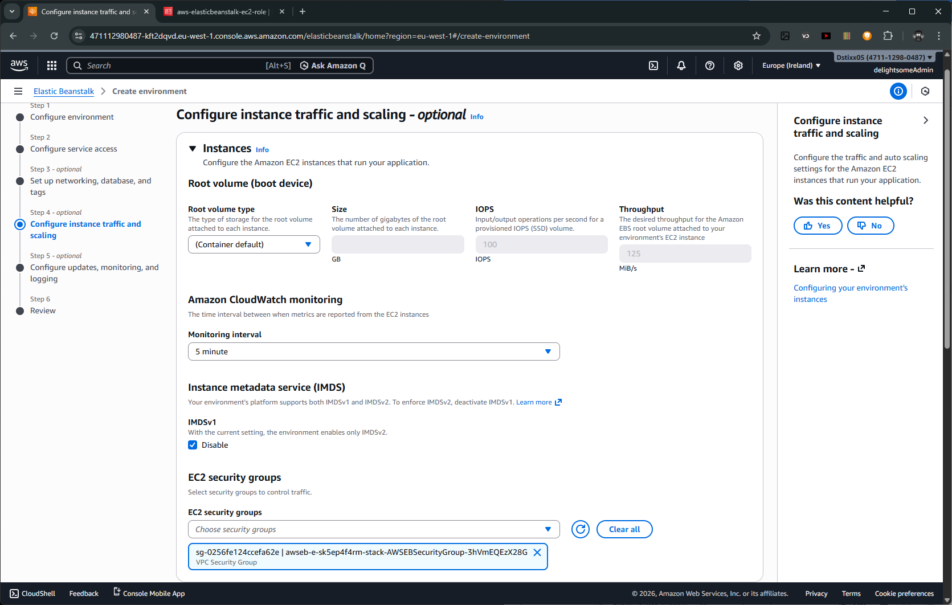
Here, we configure the root volume type, that’s the type of storage device we want to work with. We also configure our CloudWatch monitoring interval. In AWS enviornments, CloudWatch serves as the log collector and provides us with useful data for debugging and making decisions.
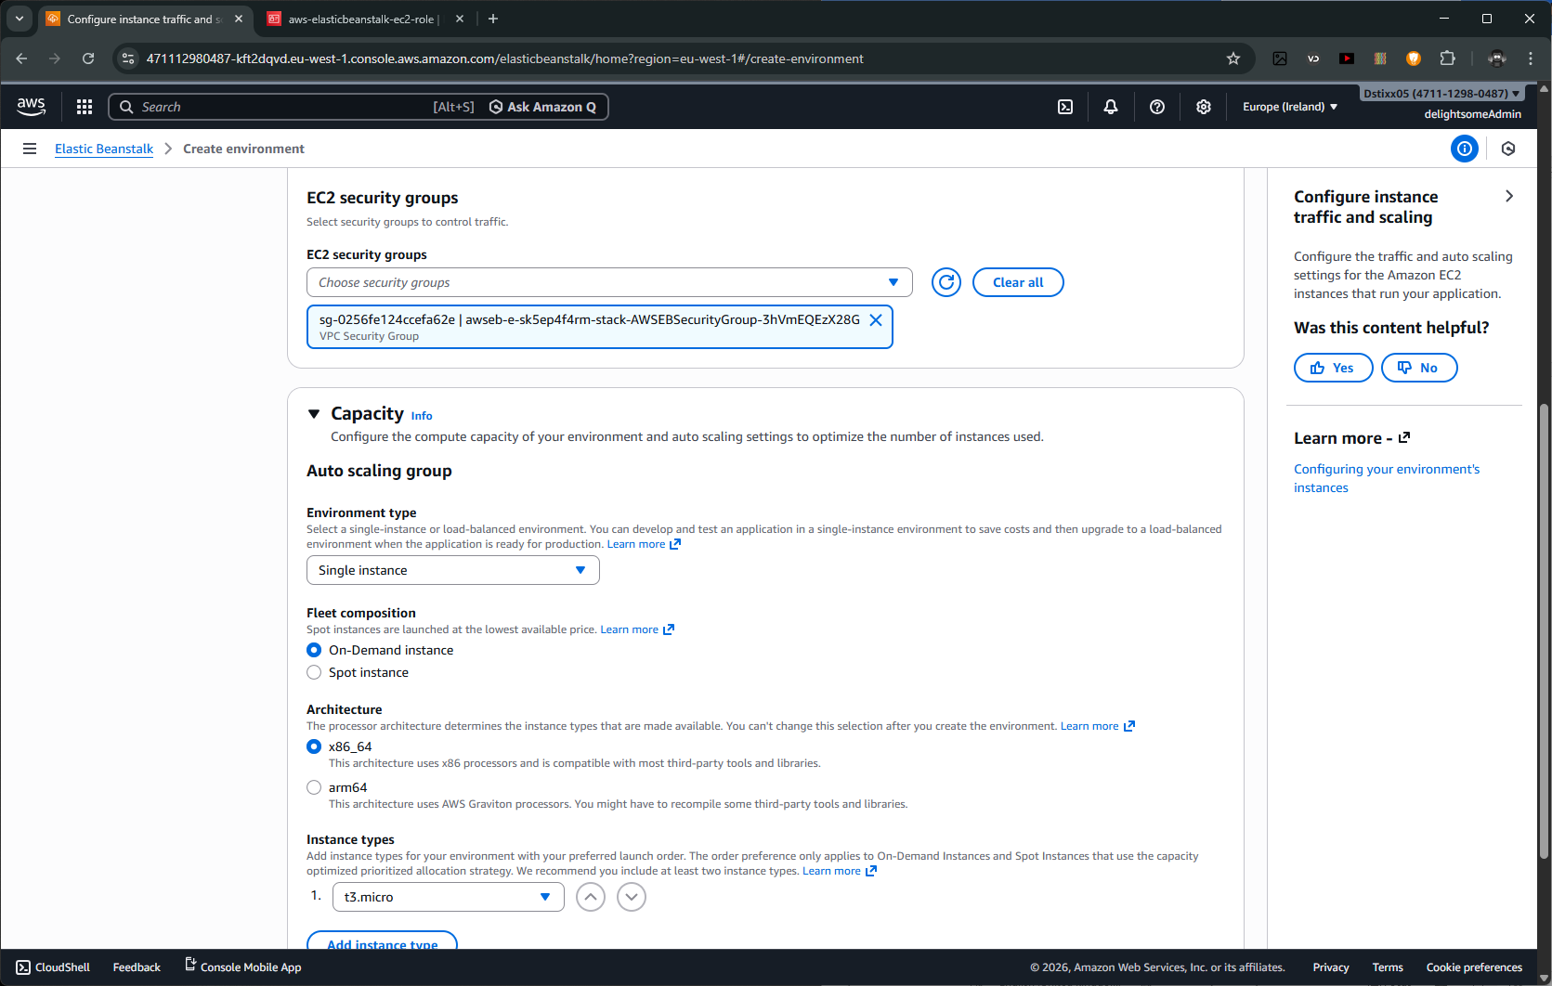Here, I set the security group to the one created particularly for beanstalk. Security groups help us set permission with modularity. We can apply security rules to a security group and add as many instance as we want the rule to apply to the security group.

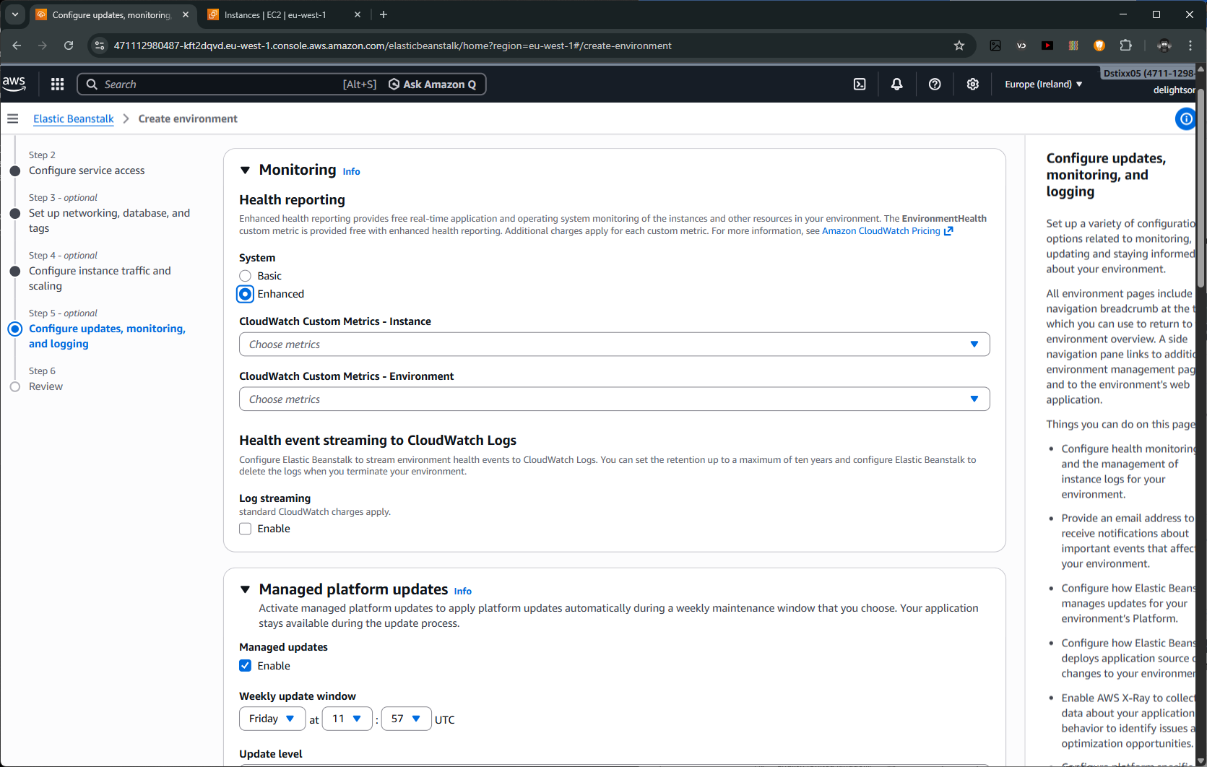Here, we configure metrics for cloudwatch, alongside update settings for when our OS wants to update. I’ll leave all these settings unchanged as they serve the purpose of the application I’m deploying.

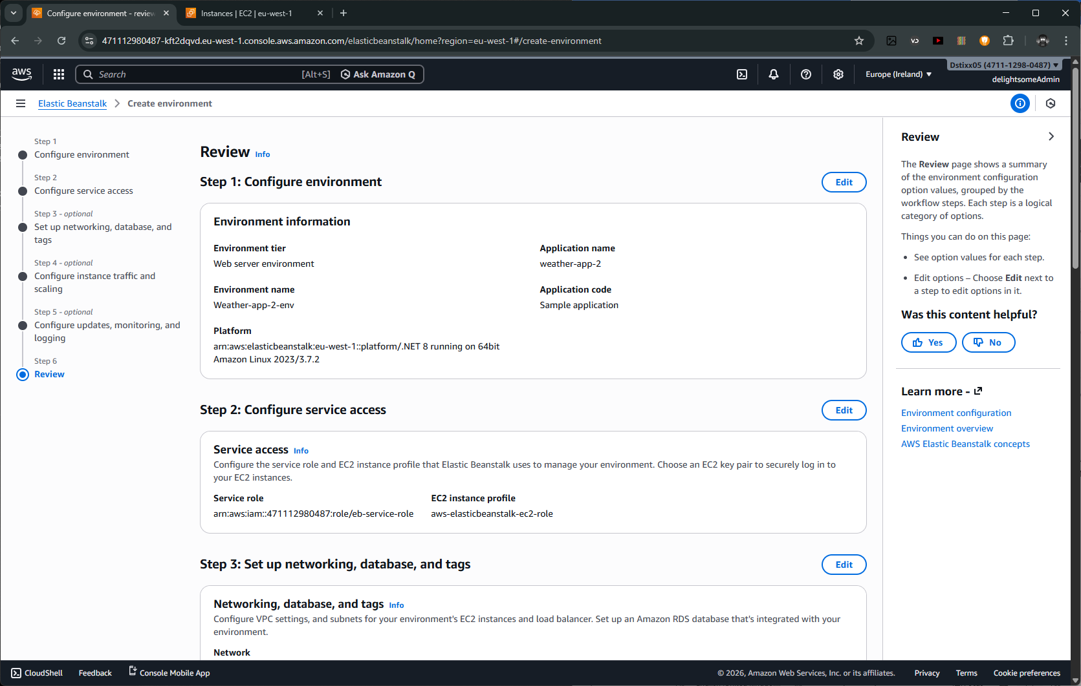Once we’re done, we’re to review what we’ve configured.

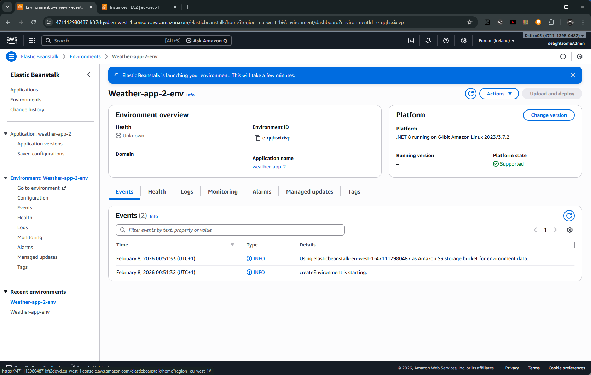
Now, we wait.
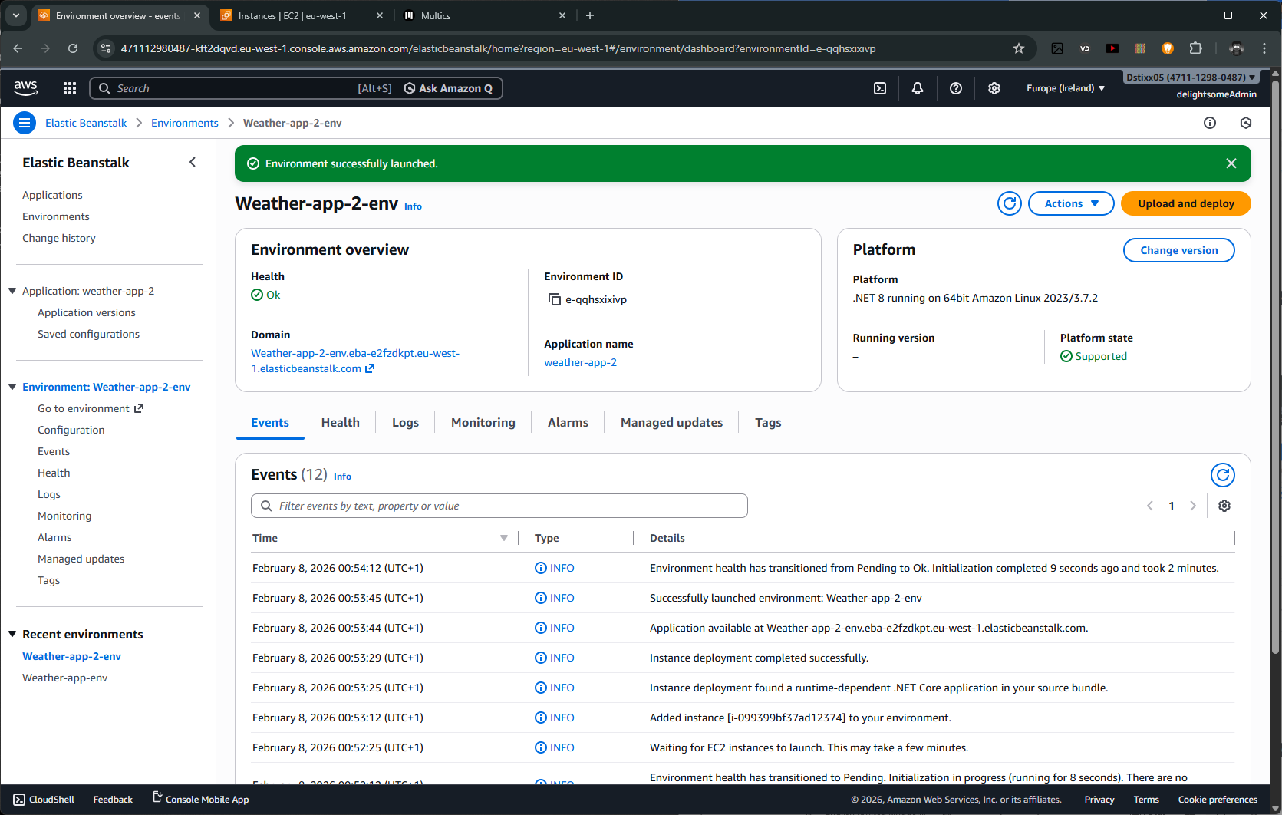
Next, click on Upload and deploy to upload and deploy your application over the internet. I already compressed mine into a zip using 7zip on my terminal. 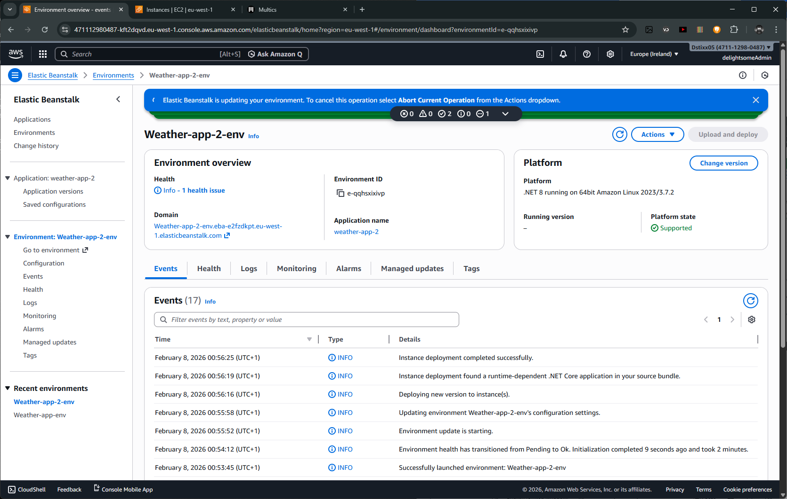
And my applocation is live
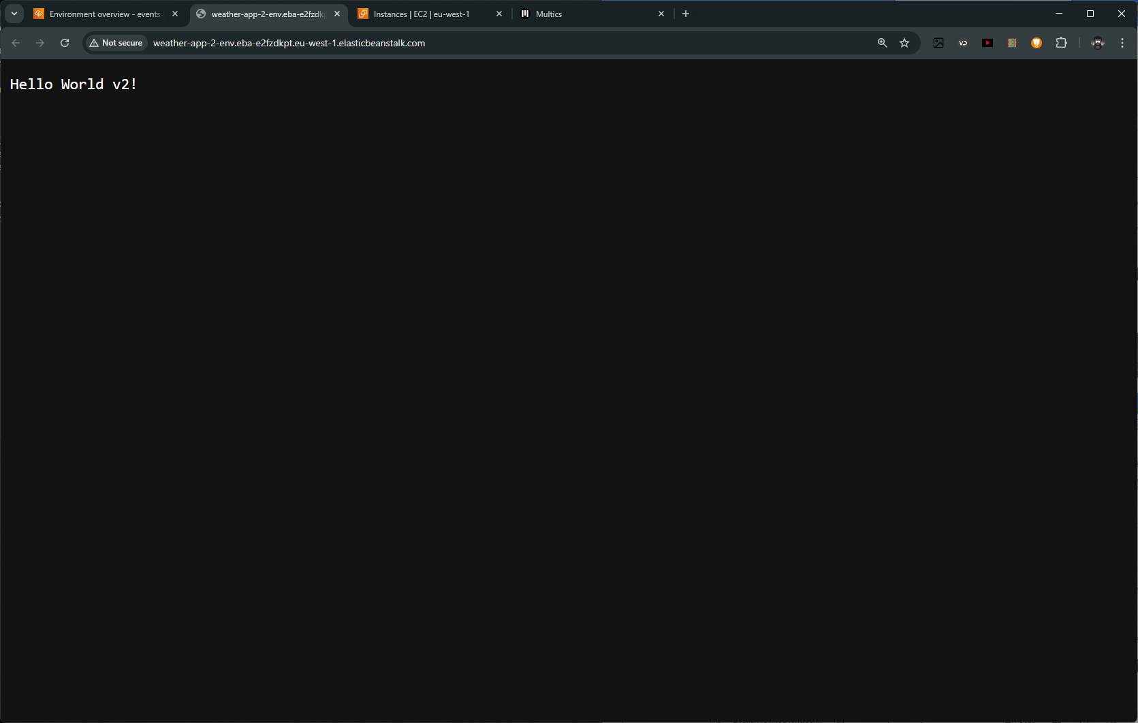
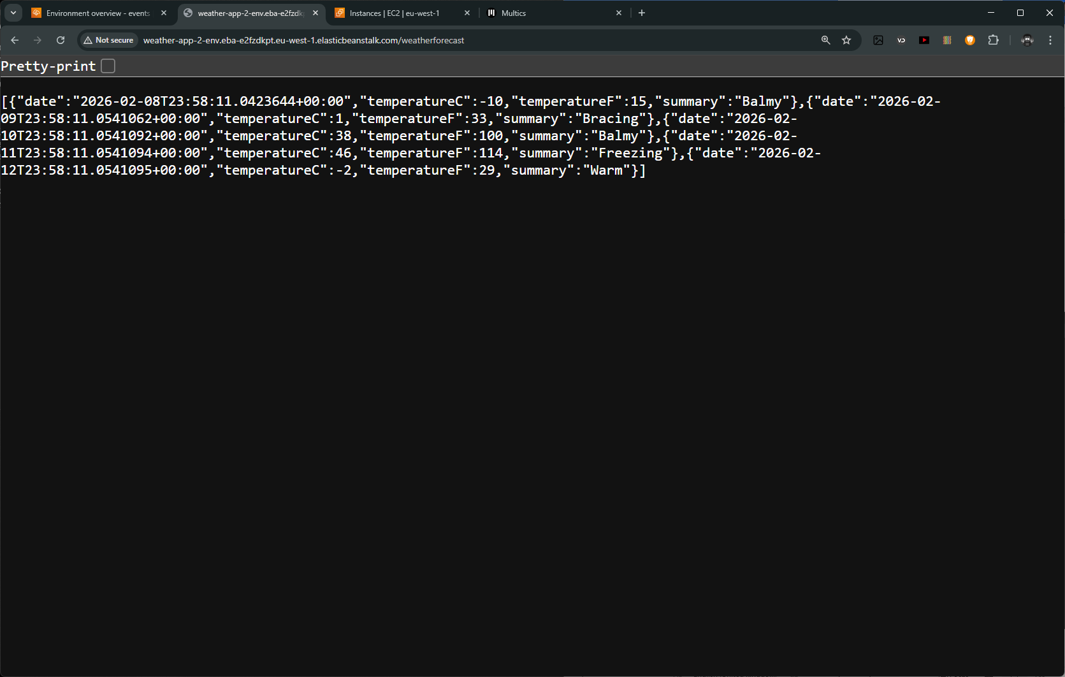

Walthrough how to compress our application using

